This word file will explain how you can import our database(photoportal.sql) into your computer for our website to work correctly.

1) Please first log in to the phpMyAdmin page:

2) Then, please create a new database which is called “photoportal”

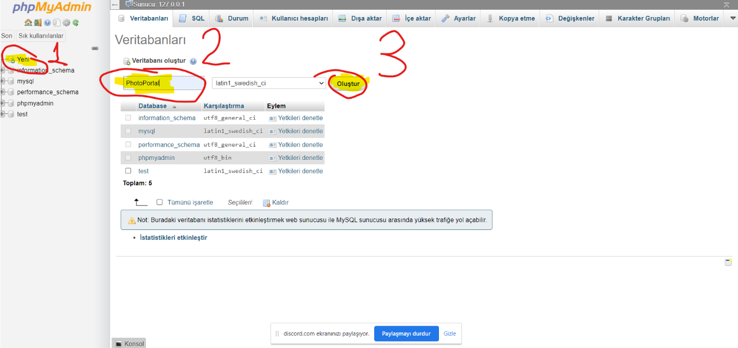

3) After that, please import the “photoportal.sql” file into the photoportal database.

4) Finally, please press the “GO” button, which is located at the right bottom of the page.

